**The Pokedex Devin’s View Documentation**

**Application Overview**

**Startup**

**Main Window**

**Search By Name**

**Filter By Type**

**Sort By Name/ Number**

**Add Window**

**Edit Window**

**Delete A Pokemon**

# Application Overview

The purpose of the Pokedex application is to allow Pokemon fans to track Pokemon that they have acquired. Information about each Pokemon will be recorded, and the user will be able to add, update, or delete a Pokemon.

# Startup

Select Devin’s View from the Views dropdown menu.

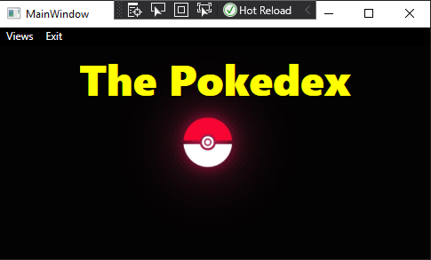

# Main Window

* Select a Pokemon name to view it.
* Information is displayed on the right hand side.
* Clicking “Reset” will reset the entire list at any time.

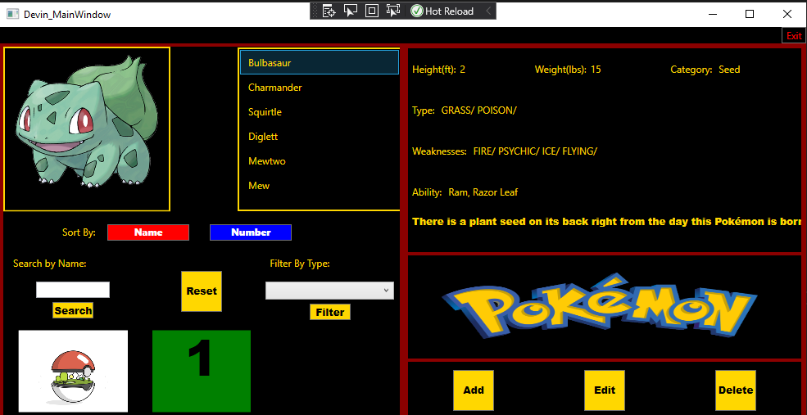

## Search By Name

* Enter a name (or partial name) into the search bar and click “Search.”

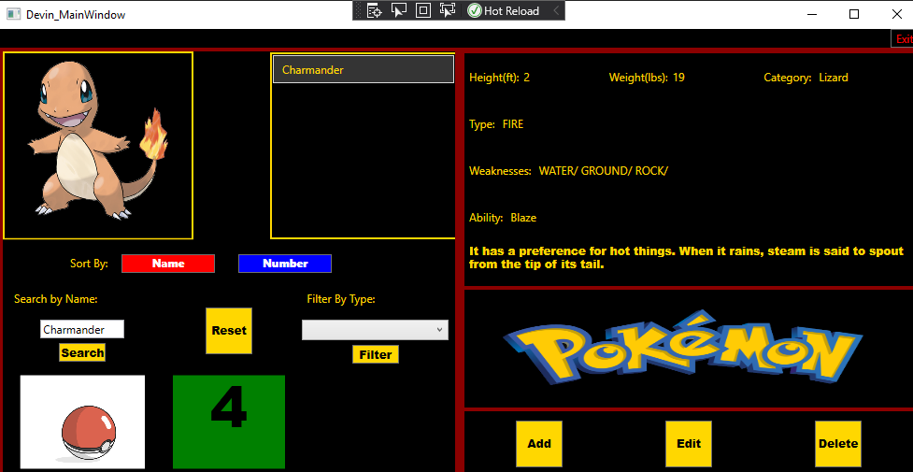

## Filter By Type

* Select a type from the drop down menu and click “Filter.”
* Pokemon that match the type selected will populate the list.

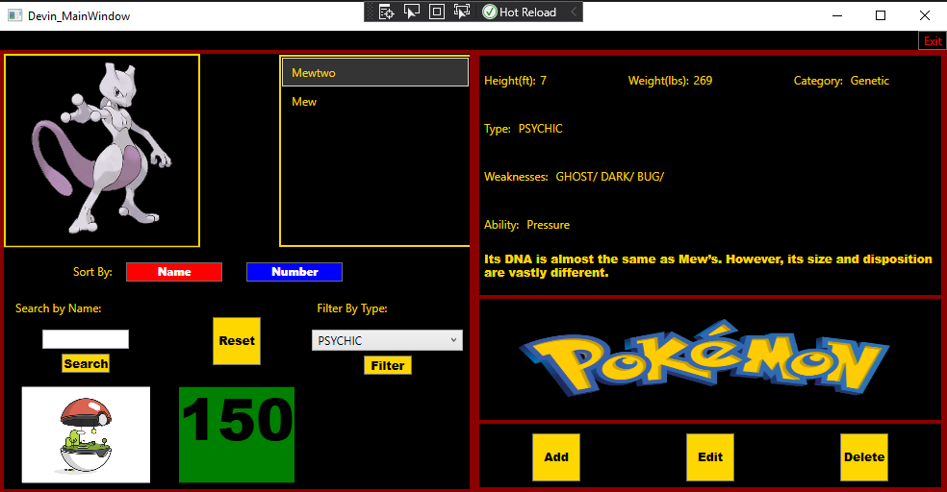

## Sort By Name/ Number

* Clicking the “Name” button will sort the list alphabetically.
* Clicking the “Number” button will sort the list by Pokemon number in ascending order.

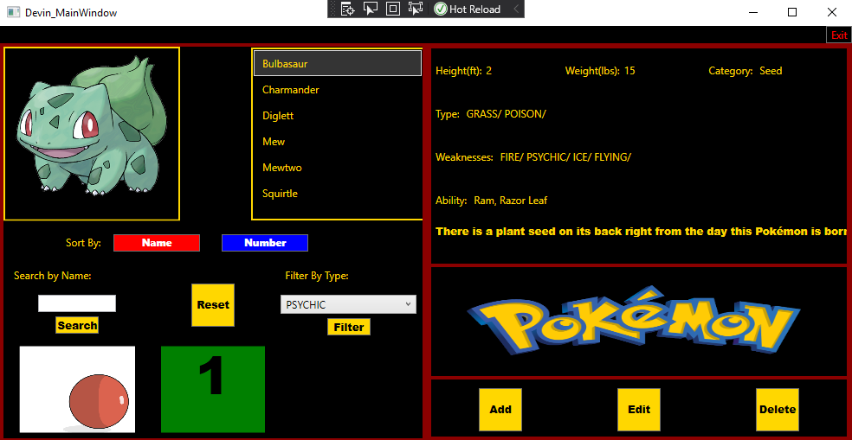

# Add Window

* Click on a desired field to enter information.
* To select a type or weakness, select an option (or multiple) from the list.
* Click on the “Image” button to insert an image (leaving it blank will use a default image).
* Click “Save” to add the Pokemon or “Cancel” to return to the main menu.

# 

* If all blocks are left blank, then a default value will be entered like the one below.

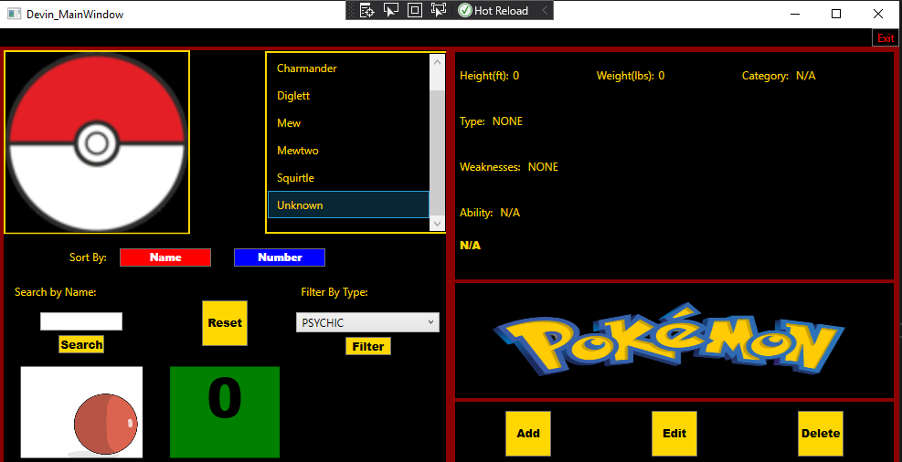

# Edit Window

* Select the Pokemon you wish to edit and click the “Edit” button.
* The Edit window opens with the current Pokemon’s information filled in.
* You can edit any field simply by selecting it.

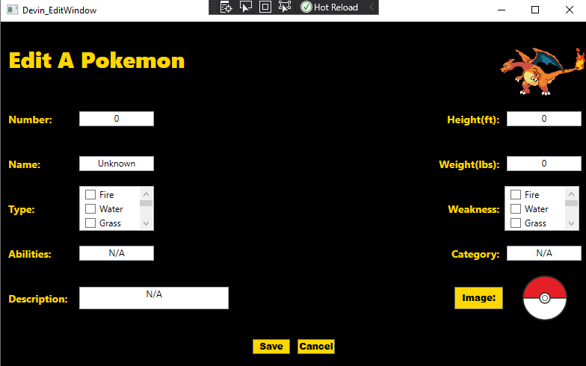

* The new information has been filled in.
* Click “Save” to save the changes or “Cancel” to return to the menu.

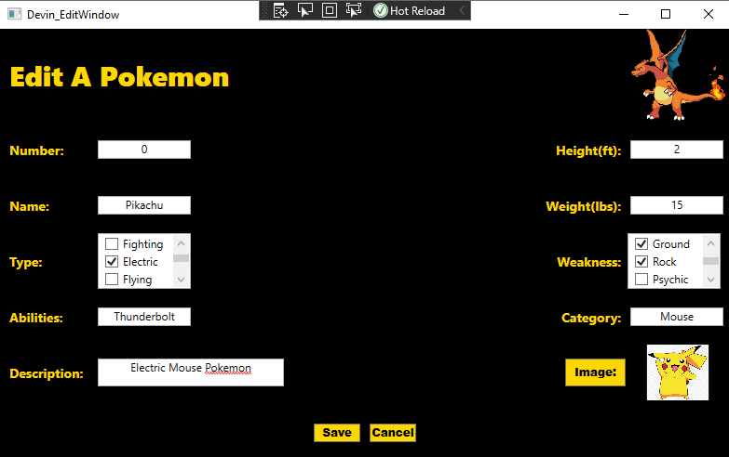

* The new information has been saved.

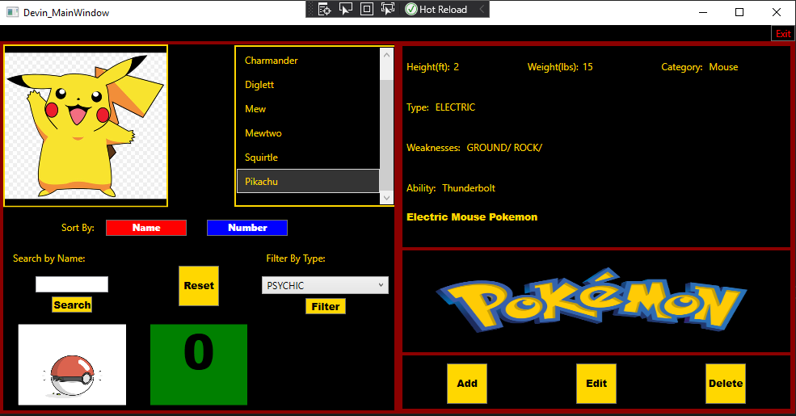

# Delete A Pokemon

* Select the Pokemon you wish to delete and click the “Delete” button.



* A dialog box appears asking you to confirm deletion.

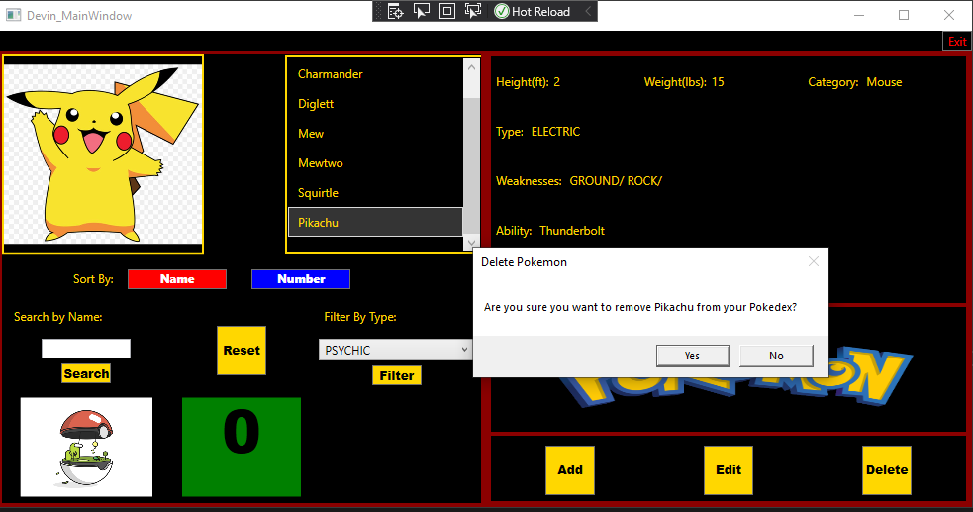

* The Pokemon has been removed from the Pokedex

